Chapter 4

# Try It Yourself: Describe the Shape of a Histogram

## Excel Instructions

### Open the videogames.csv file in Excel.

### Select the column M containing User_Rating.

### From the Excel ribbon at the top, select the Insert tab.

### To insert a histogram click on Charts → Insert Static Chart → Histogram

### Adjust the number of bins:

### Right-click the x-axis under the bins to open a navigation menu.

* 1. Select Format Axis.

### Under Bins, set the “Number of bins” to 30.

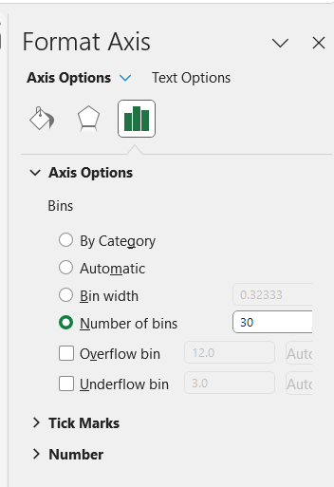

### Customize the chart:

### Set the chart title to “Histogram of User Ratings.”

### Label the x-axis as “User Rating” and the y-axis as “Frequency via Chart Design → Add Chart Element → Axis Titles.”